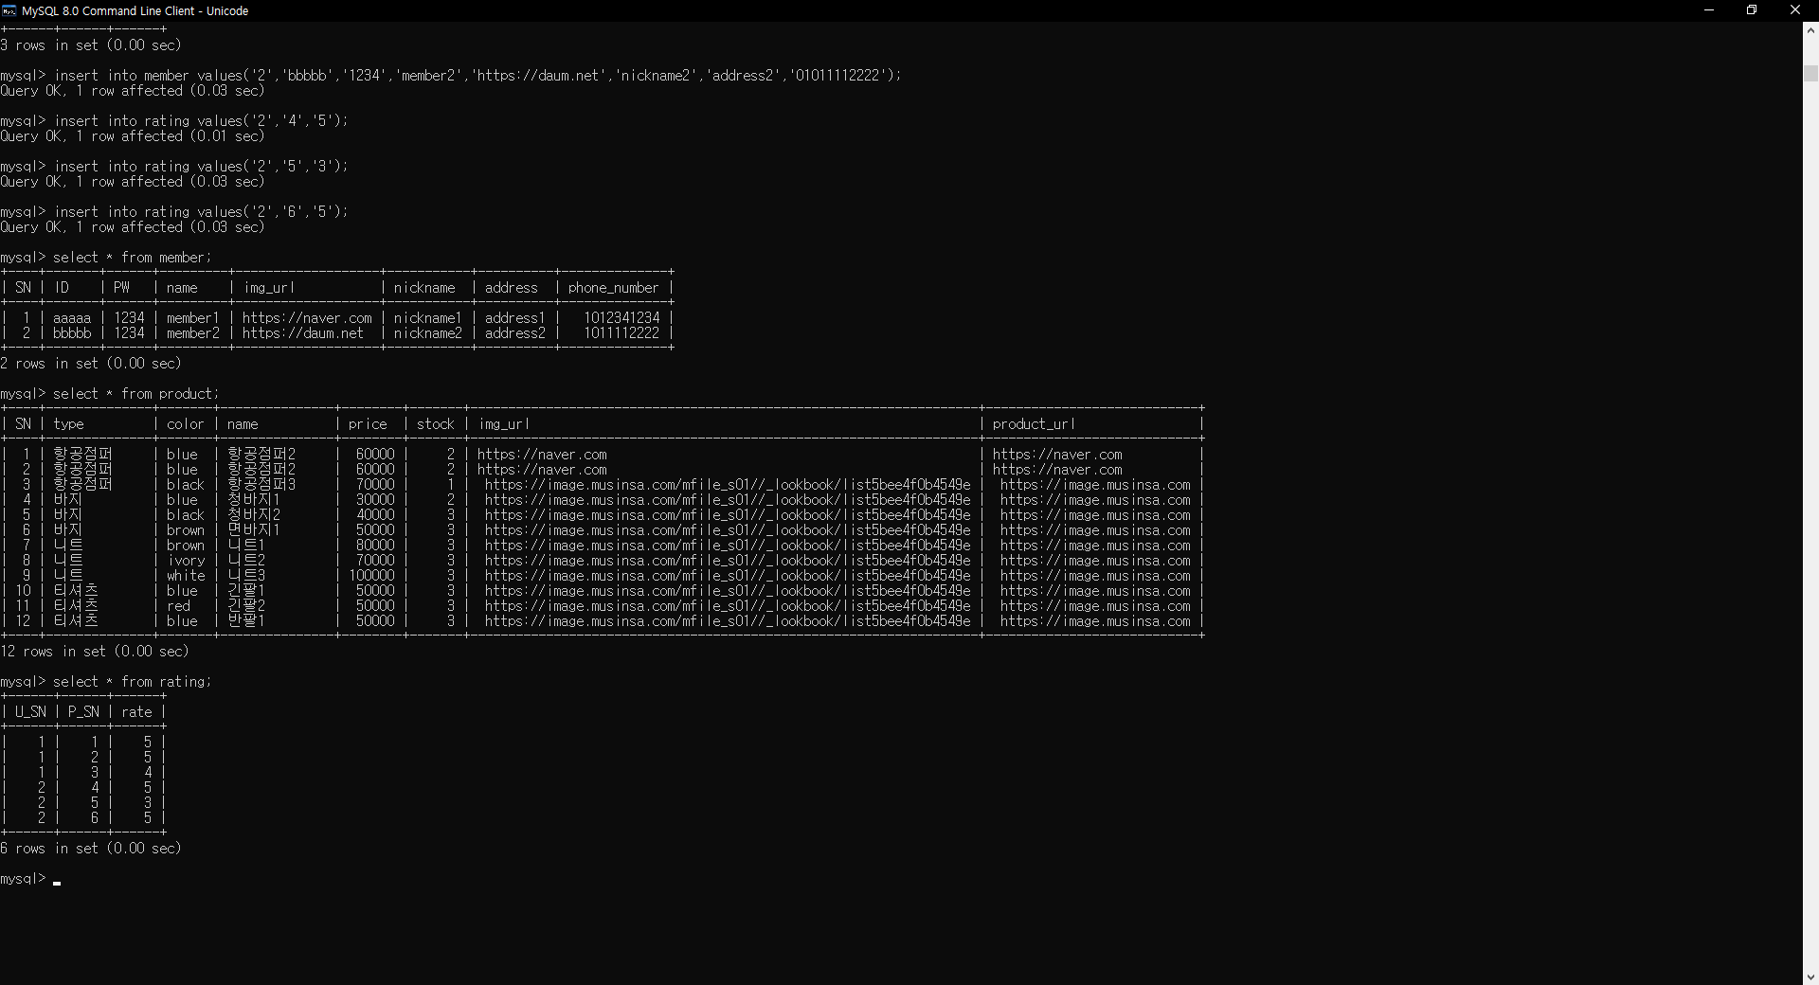

TABLE생성

CREATE TABLE Member (

SN int(11) NOT NULL AUTO_INCREMENT,

ID varchar(30) NOT NULL,

PW varchar(45) NOT NULL,

name varchar(45) NOT NULL, img_url varchar(45) DEFAULT NULL,

nickname varchar(45) NOT NULL,

address varchar(100) DEFAULT NULL,

phone_number int(11) DEFAULT NULL,

PRIMARY KEY (SN),

UNIQUE KEY ID_UNIQUE (ID),

UNIQUE KEY nickname_UNIQUE (nickname)

) ENGINE=InnoDB DEFAULT CHARSET=utf8;

CREATE TABLE Product (

SN int(11) NOT NULL AUTO_INCREMENT,

type varchar(7) NOT NULL,

color varchar(7) NOT NULL,

name varchar(45) NOT NULL,

price int(11) NOT NULL,

stock int(11) NOT NULL,

img_url varchar(100) NOT NULL,

product_url varchar(100) NOT NULL,

PRIMARY KEY (SN)

) ENGINE=InnoDB DEFAULT CHARSET=utf8;

CREATE TABLE Community_Notice (

SN int(11) NOT NULL AUTO_INCREMENT,

title varchar(45) NOT NULL,

date datetime NOT NULL,

views int(11) NOT NULL,

contents varchar(1000) DEFAULT NULL,

writer_SN int(11) NOT NULL,

PRIMARY KEY (SN),

KEY w1_idx (writer_SN),

CONSTRAINT w1 FOREIGN KEY (writer_SN) REFERENCES Member (SN) ON DELETE NO ACTION ON UPDATE CASCADE

) ENGINE=InnoDB DEFAULT CHARSET=utf8;

CREATE TABLE Community_News (

SN int(11) NOT NULL AUTO_INCREMENT,

title varchar(45) NOT NULL,

date datetime NOT NULL,

views int(11) NOT NULL,

contents varchar(1000) DEFAULT NULL,

writer_SN int(11) NOT NULL,

PRIMARY KEY (SN),

KEY w2_idx (writer_SN),

CONSTRAINT w2 FOREIGN KEY (writer_SN) REFERENCES Member (SN) ON DELETE NO ACTION ON UPDATE CASCADE

) ENGINE=InnoDB DEFAULT CHARSET=utf8;

CREATE TABLE Community_Free (

SN int(11) NOT NULL AUTO_INCREMENT,

title varchar(45) NOT NULL,

date datetime NOT NULL,

views int(11) NOT NULL,

contents varchar(1000) DEFAULT NULL,

writer_SN int(11) NOT NULL,

PRIMARY KEY (SN),

KEY w3_idx (writer_SN),

CONSTRAINT w3 FOREIGN KEY (writer_SN) REFERENCES Member (SN) ON DELETE NO ACTION ON UPDATE CASCADE

) ENGINE=InnoDB DEFAULT CHARSET=utf8;

CREATE TABLE Community_Comment_Notice (

SN int(11) NOT NULL,

contents varchar(300) NOT NULL,

wirter_SN int(11) NOT NULL,

community_SN int(11) NOT NULL,

date datetime DEFAULT NULL,

PRIMARY KEY (SN),

KEY fk_Community_Comment_Notice_1_idx (wirter_SN),

KEY fk_Community_Comment_Notice_2_idx (community_SN),

CONSTRAINT fk_Community_Comment_Notice_1 FOREIGN KEY (wirter_SN) REFERENCES Member (SN) ON DELETE NO ACTION ON UPDATE NO ACTION,

CONSTRAINT fk_Community_Comment_Notice_2 FOREIGN KEY (community_SN) REFERENCES Community_Notice (SN) ON DELETE NO ACTION ON UPDATE NO ACTION

) ENGINE=InnoDB DEFAULT CHARSET=utf8;

CREATE TABLE Community_Comment_News (

SN int(11) NOT NULL,

contents varchar(300) NOT NULL,

wirter_SN int(11) NOT NULL,

community_SN int(11) NOT NULL,

date datetime DEFAULT NULL,

PRIMARY KEY (SN),

KEY fk_Community_Comment_News_1_idx (wirter_SN),

KEY fk_Community_Comment_News_2_idx (community_SN),

CONSTRAINT fk_Community_Comment_News_1 FOREIGN KEY (wirter_SN) REFERENCES Member (SN) ON DELETE NO ACTION ON UPDATE NO ACTION,

CONSTRAINT fk_Community_Comment_News_2 FOREIGN KEY (community_SN) REFERENCES Community_News (SN) ON DELETE NO ACTION ON UPDATE NO ACTION

) ENGINE=InnoDB DEFAULT CHARSET=utf8;

CREATE TABLE Community_Comment_Free (

SN int(11) NOT NULL,

contents varchar(300) NOT NULL,

wirter_SN int(11) NOT NULL,

community_SN int(11) NOT NULL,

date datetime DEFAULT NULL,

PRIMARY KEY (SN),

KEY fk_Community_Comment_Free_1_idx (wirter_SN),

KEY fk_Community_Comment_Free_2_idx (community_SN),

CONSTRAINT fk_Community_Comment_Free_1 FOREIGN KEY (wirter_SN) REFERENCES Member (SN) ON DELETE NO ACTION ON UPDATE NO ACTION,

CONSTRAINT fk_Community_Comment_Free_2 FOREIGN KEY (community_SN) REFERENCES Community_Free (SN) ON DELETE NO ACTION ON UPDATE NO ACTION

) ENGINE=InnoDB DEFAULT CHARSET=utf8;

CREATE TABLE IF NOT EXISTS rating (

U_SN int(11) NOT NULL,

P_SN int(11) NOT NULL,

rate int(1) NOT NULL,

PRIMARY KEY (U_SN, P_SN),

FOREIGN KEY (U_SN) REFERENCES Member (SN) ON DELETE NO ACTION ON UPDATE NO ACTION,

FOREIGN KEY (P_SN) REFERENCES Product (SN) ON DELETE NO ACTION ON UPDATE NO ACTION

)ENGINE=InnoDB DEFAULT CHARSET=utf8;

DB 삽입

PRODUCT

INSERT INTO product values(1, '항공점퍼', 'red', '항공점퍼1', 50000, 2, 'sd.com/mfile_s01//_lookbook/list5bee4f0b4549e', 'https://image.musinsa.com');

INSERT INTO product values(2, '항공점퍼', 'blue', '항공점퍼2', 60000, 2, 'https://image.musinsa.com/mfile_s01//_lookbook/list5bee4f0b4549e', 'https://image.musinsa.com');

INSERT INTO product values(3, '항공점퍼', 'black', '항공점퍼3', 70000, 1, 'https://image.musinsa.com/mfile_s01//_lookbook/list5bee4f0b4549e', 'https://image.musinsa.com');

INSERT INTO product values(4, '바지', 'blue', '청바지1', 30000, 2, 'https://image.musinsa.com/mfile_s01//_lookbook/list5bee4f0b4549e', 'https://image.musinsa.com');

INSERT INTO product values(5, '바지', 'black', '청바지2', 40000, 3, 'https://image.musinsa.com/mfile_s01//_lookbook/list5bee4f0b4549e', 'https://image.musinsa.com');

INSERT INTO product values(6, '바지', 'brown', '면바지1', 50000, 3, 'https://image.musinsa.com/mfile_s01//_lookbook/list5bee4f0b4549e', 'https://image.musinsa.com');

INSERT INTO product values(7, '니트', 'brown', '니트1', 80000, 3, 'https://image.musinsa.com/mfile_s01//_lookbook/list5bee4f0b4549e', 'https://image.musinsa.com');

INSERT INTO product values(8, '니트', 'ivory', '니트2', 70000, 3, 'https://image.musinsa.com/mfile_s01//_lookbook/list5bee4f0b4549e', 'https://image.musinsa.com');

INSERT INTO product values(9, '니트', 'white', '니트3', 100000, 3, 'https://image.musinsa.com/mfile_s01//_lookbook/list5bee4f0b4549e', 'https://image.musinsa.com');

INSERT INTO product values(10, '티셔츠', 'blue', '긴팔1', 50000, 3, 'https://image.musinsa.com/mfile_s01//_lookbook/list5bee4f0b4549e', 'https://image.musinsa.com');

INSERT INTO product values(11, '티셔츠', 'red', '긴팔2', 50000, 3, 'https://image.musinsa.com/mfile_s01//_lookbook/list5bee4f0b4549e', 'https://image.musinsa.com');

INSERT INTO product values(12, '티셔츠', 'blue', '반팔1', 50000, 3, 'https://image.musinsa.com/mfile_s01//_lookbook/list5bee4f0b4549e', 'https://image.musinsa.com');

INSERT INTO product values(13, '티셔츠', 'yellow', '반팔2', 50000, 3, 'https://image.musinsa.com/mfile_s01//_lookbook/list5bee4f0b4549e', 'https://image.musinsa.com');

INSERT INTO product values(14, '항공점퍼', 'blue', '항공점퍼2', 60000, 2, 'https://naver.com', 'https://naver.com');

INSERT INTO product values(15, '항공점퍼', 'blue', '항공점퍼2', 60000, 2, 'https://naver.com', 'https://naver.com');

INSERT INTO member values(1, 'aaaaa', '1234', 'member1', 'https://naver.com', 'nickname1', 'address1', 01012341234);

INSERT INTO member values(2, 'bbbbb', '1234', 'member2', 'https://daum.net', 'nickname2', 'address2', 01011112222);

INSERT INTO rating values('1','1','5');

INSERT INTO rating values('1','2','4');

INSERT INTO rating values('1','3','5');

INSERT INTO rating values('2','4','5');

INSERT INTO rating values('2','5','4');

INSERT INTO rating values('2','6','5');

테이블 특성 변경:

ALTER TABLE 테이블 MODIFY 특성 변경사항;

EX)

ALTER TABLE product MODIFY img_url varchar(100) not null;

DB 삽입:

INSERT INTO 테이블 values(‘1234’,’1234’);

EX)